<https://docs.google.com/forms/d/e/1FAIpQLSckEh4EaFZOjpvKR2IJdbsY3al6lNzG2AS9rqh7r-hNoI4W8g/viewform>

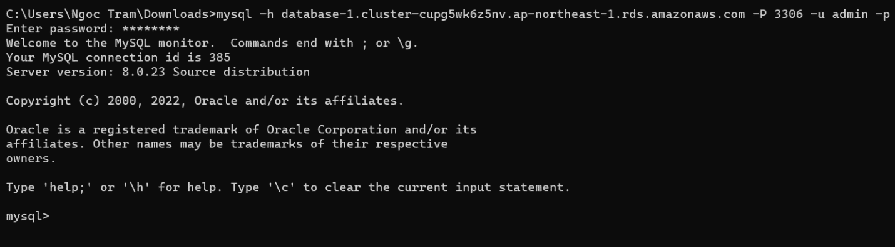

Connect to Aurora DB

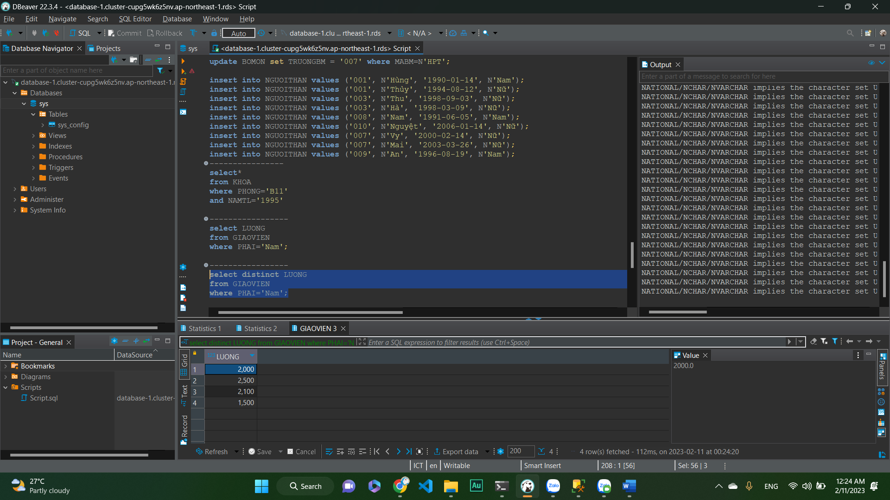

Use DBeaver to connect and create DB in Aurora DB

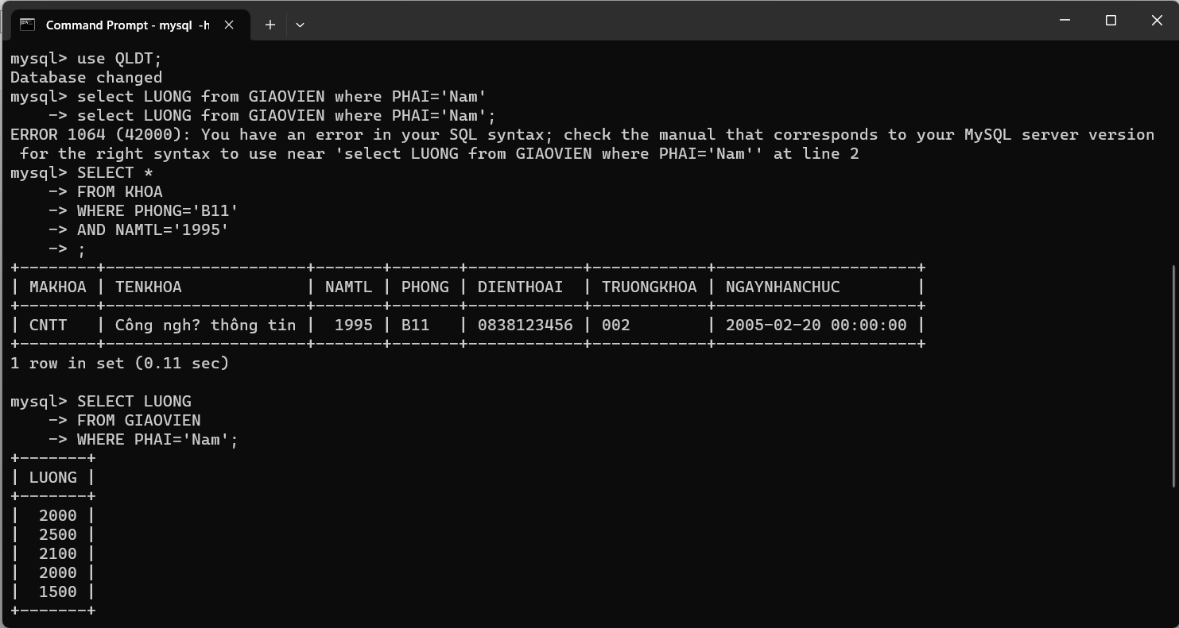

Query DB

Explain how relational database storage engines can recover from errors.  
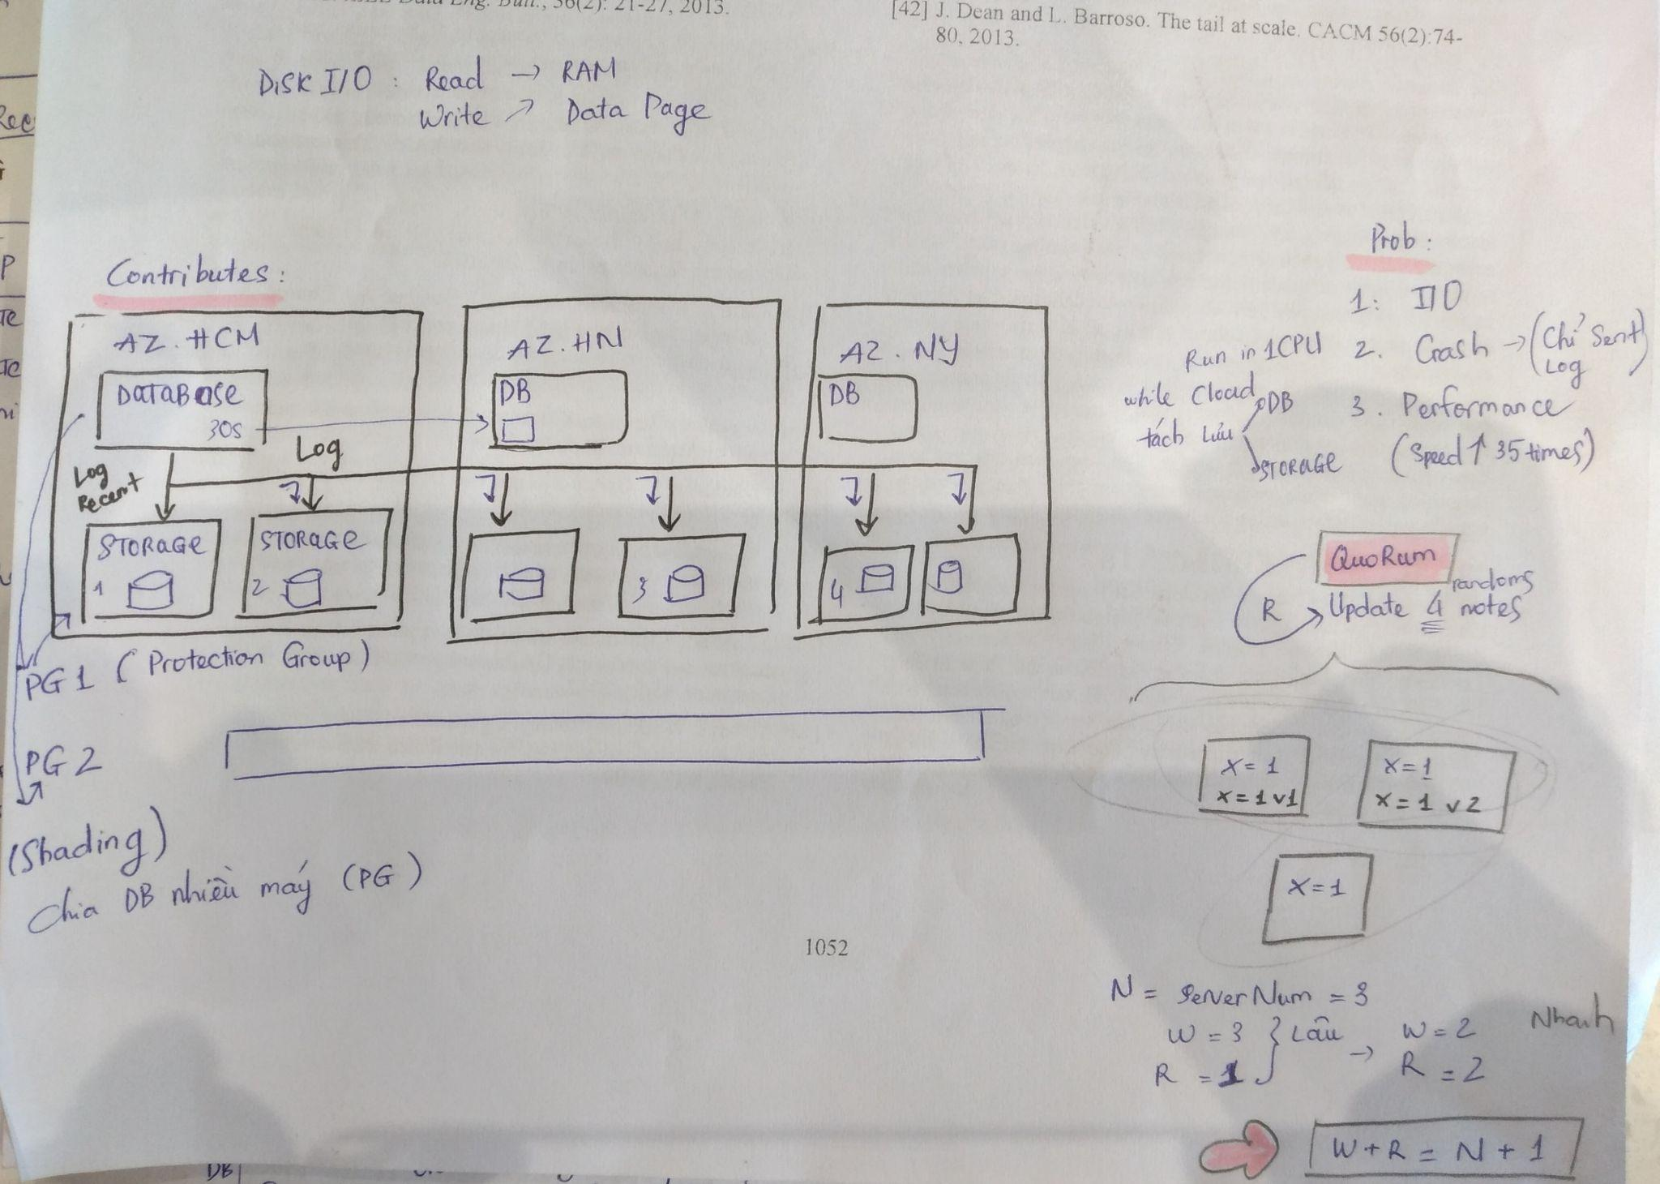

Explain how quorums work.

Describe how replication writes work in a mirrored MySQL database using a sequence diagram.  
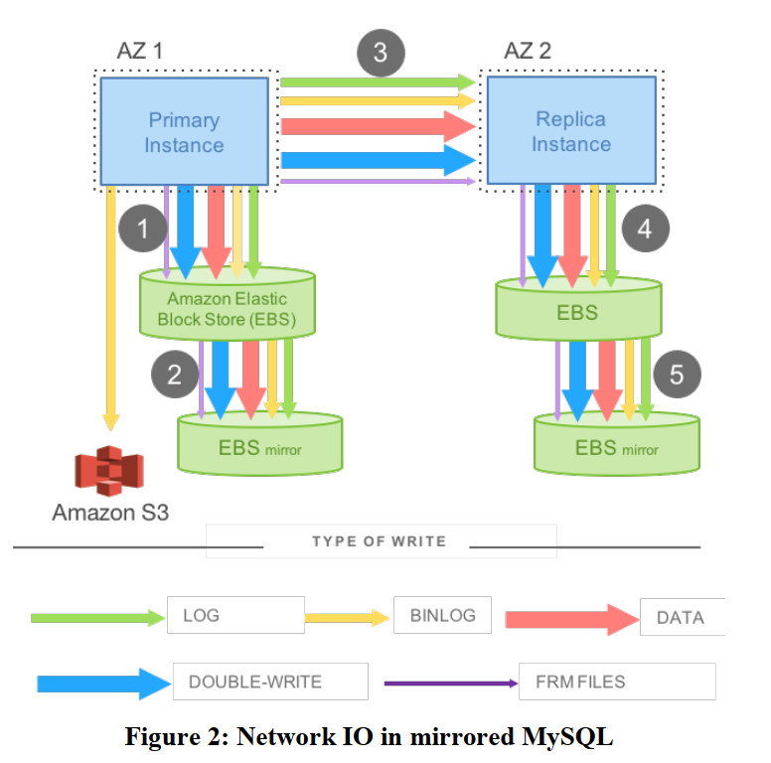

Describe how replication writes work in an Aurora MySQL database using a sequence diagram.

